Twitter

🎓 Definition
# Source: ScreenShots Source: Provided by: [Persons Table -> ID Column: 1, Name_En Column: Motasem Essam] -> Tool: [Lightshot Program] -> From [Site: https://x.com/] on [11/15/2025]
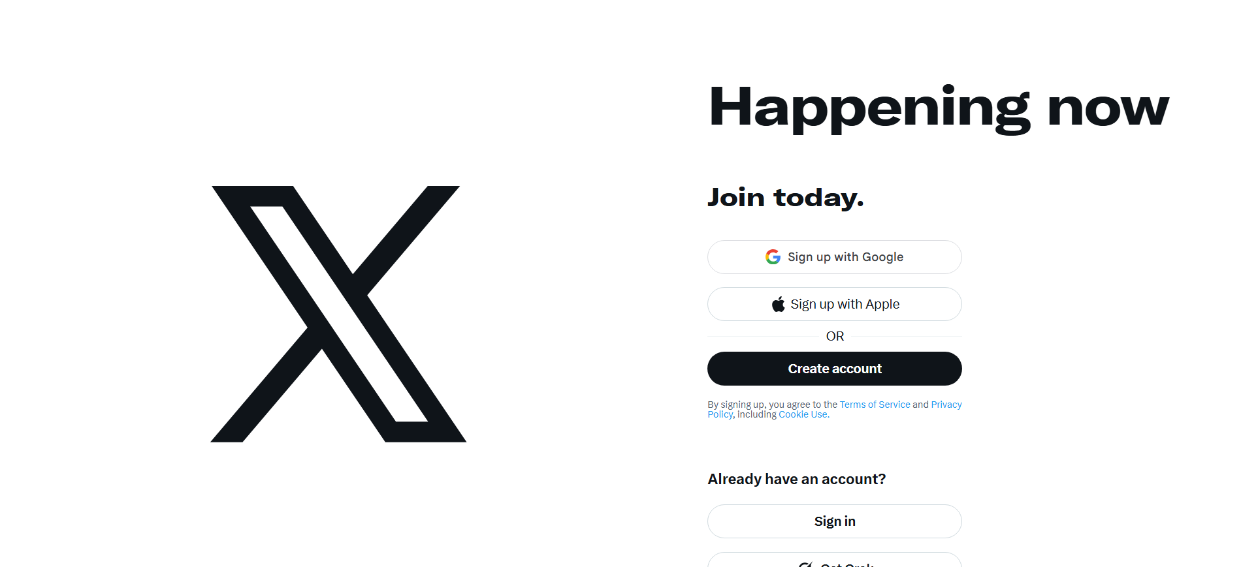
# Source: AI Source: Provided by: [Data Path: Persons Table -> ID Column: 1, Name_En Column: Motasem Essam] -> From: [ChatGPT] on [11/15/2025]
Twitter (now rebranded as X) is a global social networking and microblogging service where users post short messages (originally called “tweets,” now “posts”), which can include text, images, videos, and links. (Wikipedia)

🎯 Purpose
# Source: AI Source: Provided by: [Data Path: Persons Table -> ID Column: 1, Name_En Column: Motasem Essam] -> From: [ChatGPT] on [11/15/2025]
- To share real-time updates, news, and personal thoughts. (Webopedia)
- To connect people, allowing users to follow others, engage in conversations, and interact with public figures or brands. (TechTarget)
- With the rebrand to X, the owner (Elon Musk) aims to evolve it into a more all-in-one “everything app” integrating more features like payments, communication, and media. (CBS News)

🛡️ Safety & Legality
# Source: AI Source: Provided by: [Data Path: Persons Table -> ID Column: 1, Name_En Column: Motasem Essam] -> From: [ChatGPT] on [11/15/2025]
- The platform is legal and widely used; it operates under standard social media business and content policies. (Internet Matters)
- There are safety features (content moderation, age restrictions) — for example, users under 13 are not allowed. (Better Internet for Kids)
- Because it’s a public platform, disinformation and content misuse can be a concern; this is part of broader regulatory and safety discussions. (AP News)

📄 Summary
# Source: AI Source: Provided by: [Data Path: Persons Table -> ID Column: 1, Name_En Column: Motasem Essam] -> From: [ChatGPT] on [11/15/2025]
Twitter (now X) is a microblogging social network for sharing short posts, media, and links. It’s used by individuals, organizations, and public figures to communicate globally in real time. While safe and legal, like other large social platforms, it faces challenges around content moderation and misinformation.

